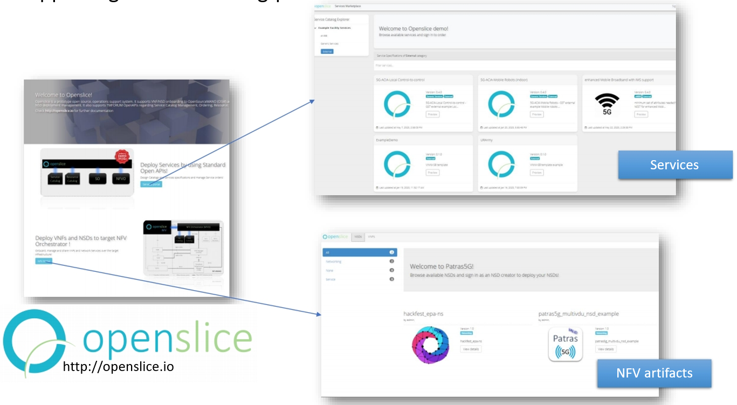

Openslice allows Vertical Customers to browse the available offered service specifications and also allows NFV developers to onboard and manage VNF and Network Service artifacts. There are two portals offering UI friendly access to users:

* The Services portal allows users to access services and service providers to design services.
* The NFV portal allows users to self-manage NFV artifacts and onboard them to a target MANO/NFV Orchestrator.

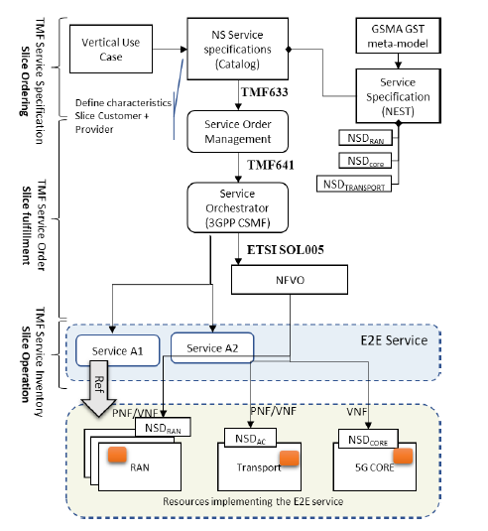

3rd party applications can use Openslice through TMForum Open APIs. In general Openslice offers the following main functionalities:

* Service Catalog Management: A Communication Services Provider will have the ability to manage the Service Catalog Items, their attributes, organize in categories and decide what to make available to Customers . Contains the representation of Service Specifications, either created from the provider defining service attributes, or by supporting the GSMA Generic Slice Templates (GST) as well as the VINNI Service Blueprint.
* Services Specifications: A CSP will be able to manage Service Specifications
* Service Catalog Exposure: A CSP will be able to expose catalog to customers and related parties
* Service Catalog to Service Catalog: Openslice able to consume and provide Service Catalog items to other catalogs
* Service Order: The Customer will be able to place a Service Order
* Service Inventory: The Customer and Provider will be able to view deployed Services status

Openslice thus support both APIs for programmable access to the infrastructure as well as a web portal for user friendly access.

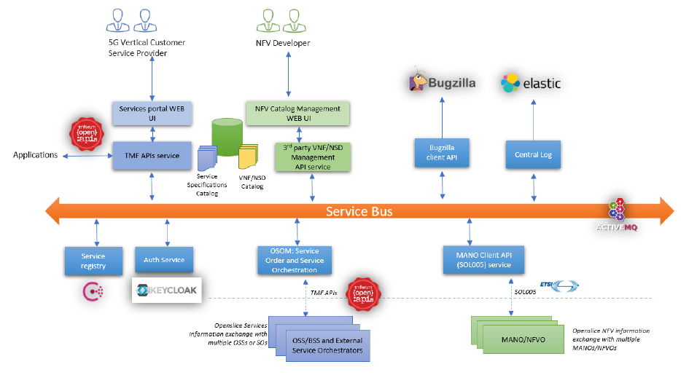

Openslice allows Vertical Customers browsing the available offered service specifications. It consists of:

* Web frontend UIs that consist of mainly two portals: i) a NFV portal allowing users self-service management and onboarding VNFDs/NSDs to facility’s NFVO ii) a Services Portal, which allows users to browse the Service Catalog, Service Blueprints specifications and the Service Inventory
* An API gateway that proxies the internal APIs and used by the web front end as well as any other 3rd party service
* A Message Bus where all microservices use it to exchange messages either via message queues or via publish/subscribe topics
* An authentication server implementing Oauth2 authentication scheme
* A microservice offering TMF compliant API services (eg Service Catalog API, Service Ordering APIetc)
* A microservice offering NFV API services (eg VNF/NSD onboarding etc) and allows to store VNFDs and NSDs in a catalog
* A microservice that is capable to interface to an issue management system. For example it raises an issue to all related stakeholders that a new Service Order is requested
* Central logging microservice that is capable to log all distributed actions in to an Elasticsearch cluster
* A Service Orchestrator solution that will propagate Service Ordering requests to the equivalent SOs and NFVOs

Next table provides a list of technologies.

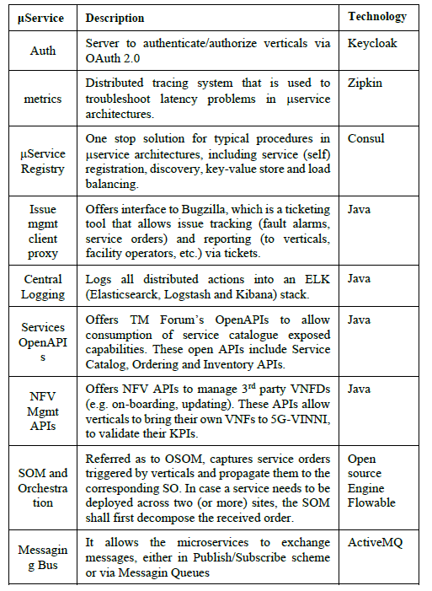

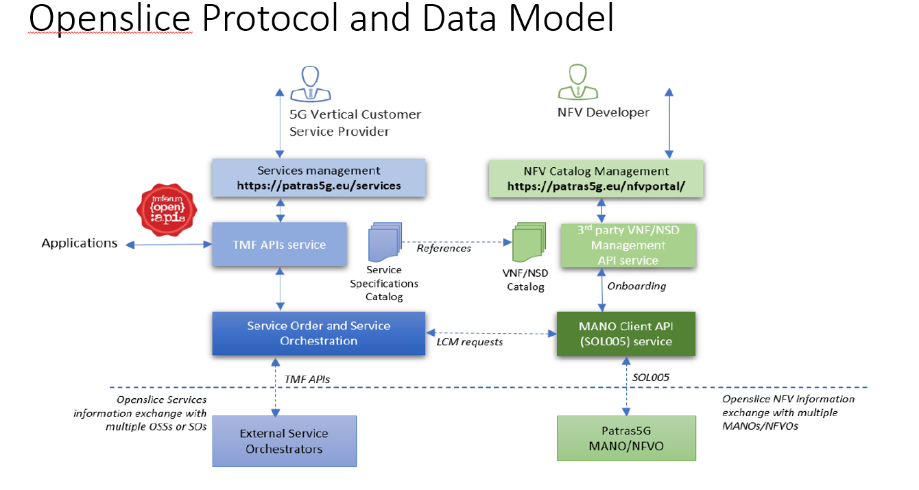

OpenSlice illustrates the Network Slice as a Service (NSaaS) delivery model, whereby each facility provisions tailored network slices to verticals upon request. Each vertical uses the slice that has been provided to meet their requirements for trialing activities, setting up different use cases and assessing their KPIs under different network conditions. The high-level architecture which allows NSaaS delivery model where the Openslice portal and service catalogue expose TM Forum Open APIs towards verticals to allow them to directly trigger necessary operations for service ordering. The Service Catalogue derives content from Facility Service Catalogue offerings hosted by the respective Service Orchestrators (SO). The service order is then passed to the SO in the facility site. The SO, which implements the 3GPP Network Slice Management Functionality (taking the roles of both Network Slice Management Function (NSMF) and Network Slice Subnet Management Function (NSSMF)), then instantiates the network slice by subsequent calls to the respective network function orchestrator (NFVO).

The Network Orchestrator is interconnected with a NFVO (NFV Orchestrator), which orchestrates instances of VNFs and network services with the help of a Virtualized Infrastructure Manager (VIM). The VIM manages the virtual resources on top of which those instances are executed.

The NFVO implements the northbound interface using ETSI SOL 005. ( RESTful APIs )

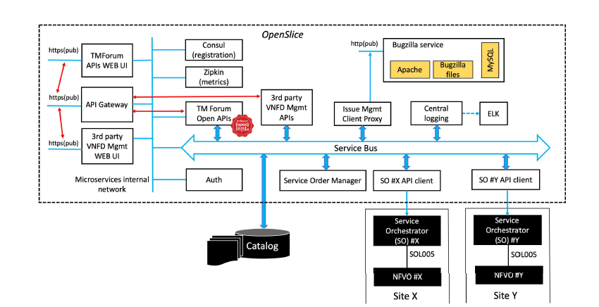

In general, the portal includes set of loosely coupled modules exchanging messages via a message/routing service bus, following microservice architecture. Based on Apache Camel, this service bus allows communication across the different microservices either via message queues or via ‘publish/subscription’ model. These microservices help the facility to manage (e.g. authorize, audit) the interactions between verticals and the service catalog, including catalog browsing, service ordering and service inventory related operations. To allow verticals to gain access to the framework, and hence to the facility, OpenSlice offers the web frontend, with two UIs. This web frontend is implemented in Angular and interacts with the OpenSlice backend API using an API proxy.

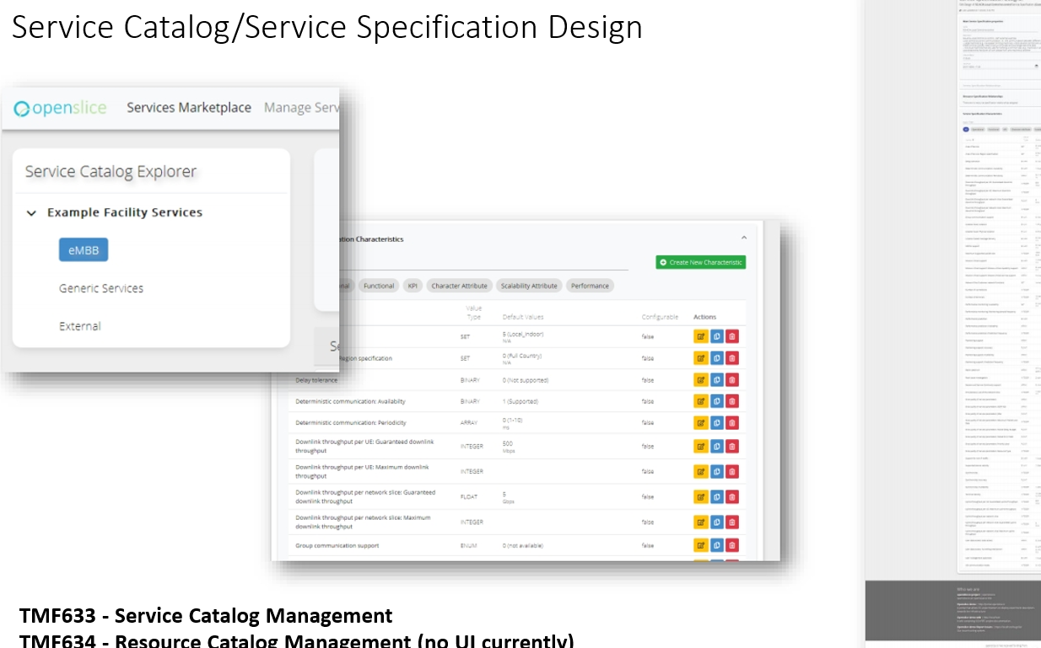

Referring to the Service offering two structures are defined to allow verticals to quickly bring their use cases into openslice and subsequently into the facility. These are the:

1. the Service Blueprint (SB), and

2. the Service Catalogue (SC).

The SBs announced by each facility site are registered and published into a single service catalogue. This approach allows providing verticals with a unified marketplace, informing them about available service offerings in the entire facility. The Service Catalog offers various ways to access the defined Service Specifications, organized in categories (e.g. eMBB, Networking, edge, etc). Customers can browse the publicly available catalog and see offered services.

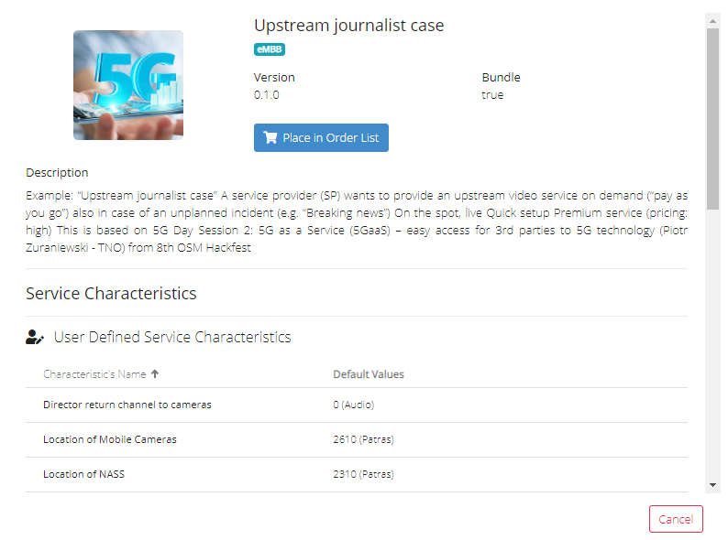

Details of each service are available, so that the customer can understand underlying details, as well as the underlying attributes of the service offered. Also any user defined attributes as well as ways to access the final operation service are also available. All this information is made from the Service Specification design.

Any authorized vertical is in position to browse the SC, select a SB, fill it according to the service requirements, and issue a service order. Upon receiving this service order, the facility proceeds with the CFS-RFS translation, mapping the service order (CFS) into a network slice instance (RFS), deployed across one or more facility sites.

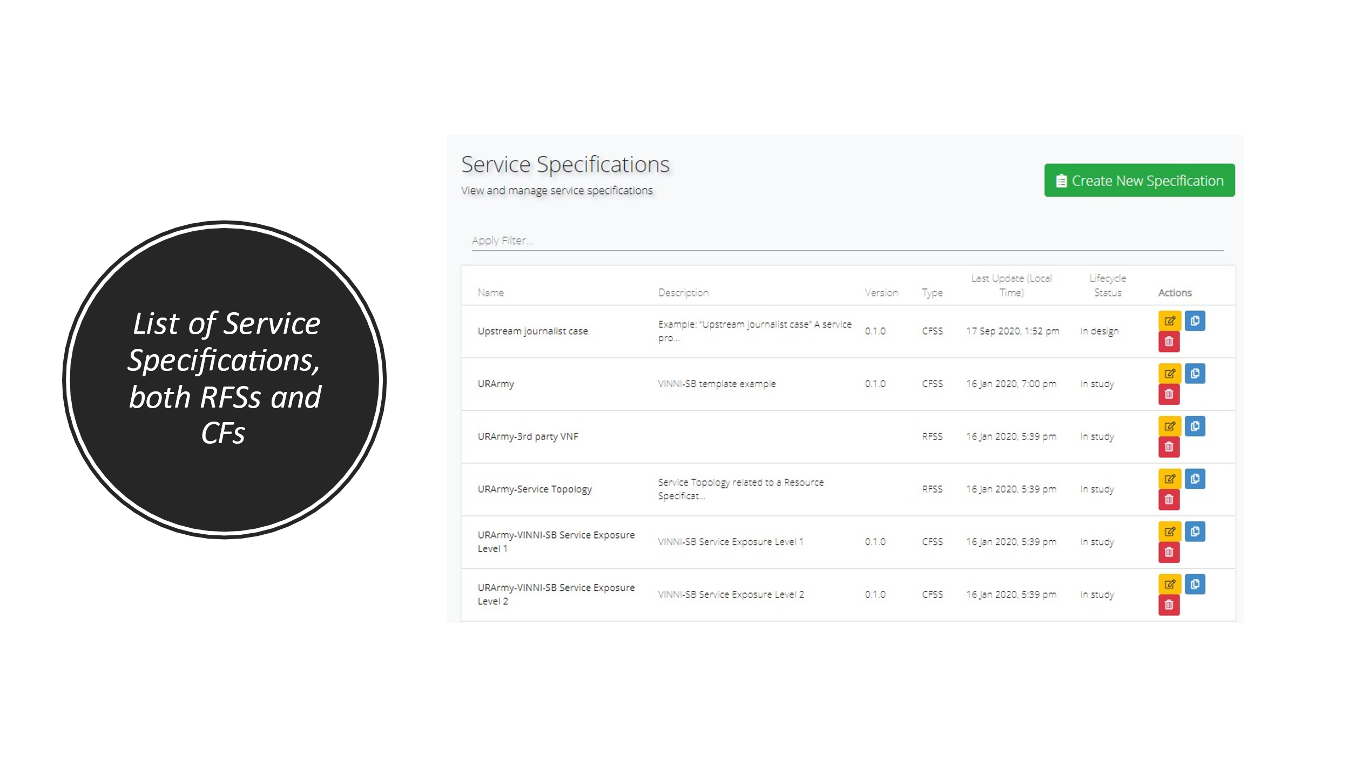

Figure displays a list of available CFSs and RFSs in the system. This is available to the service developers and admins. They can use it to construct new Services as bundles: Services that are related with other services.

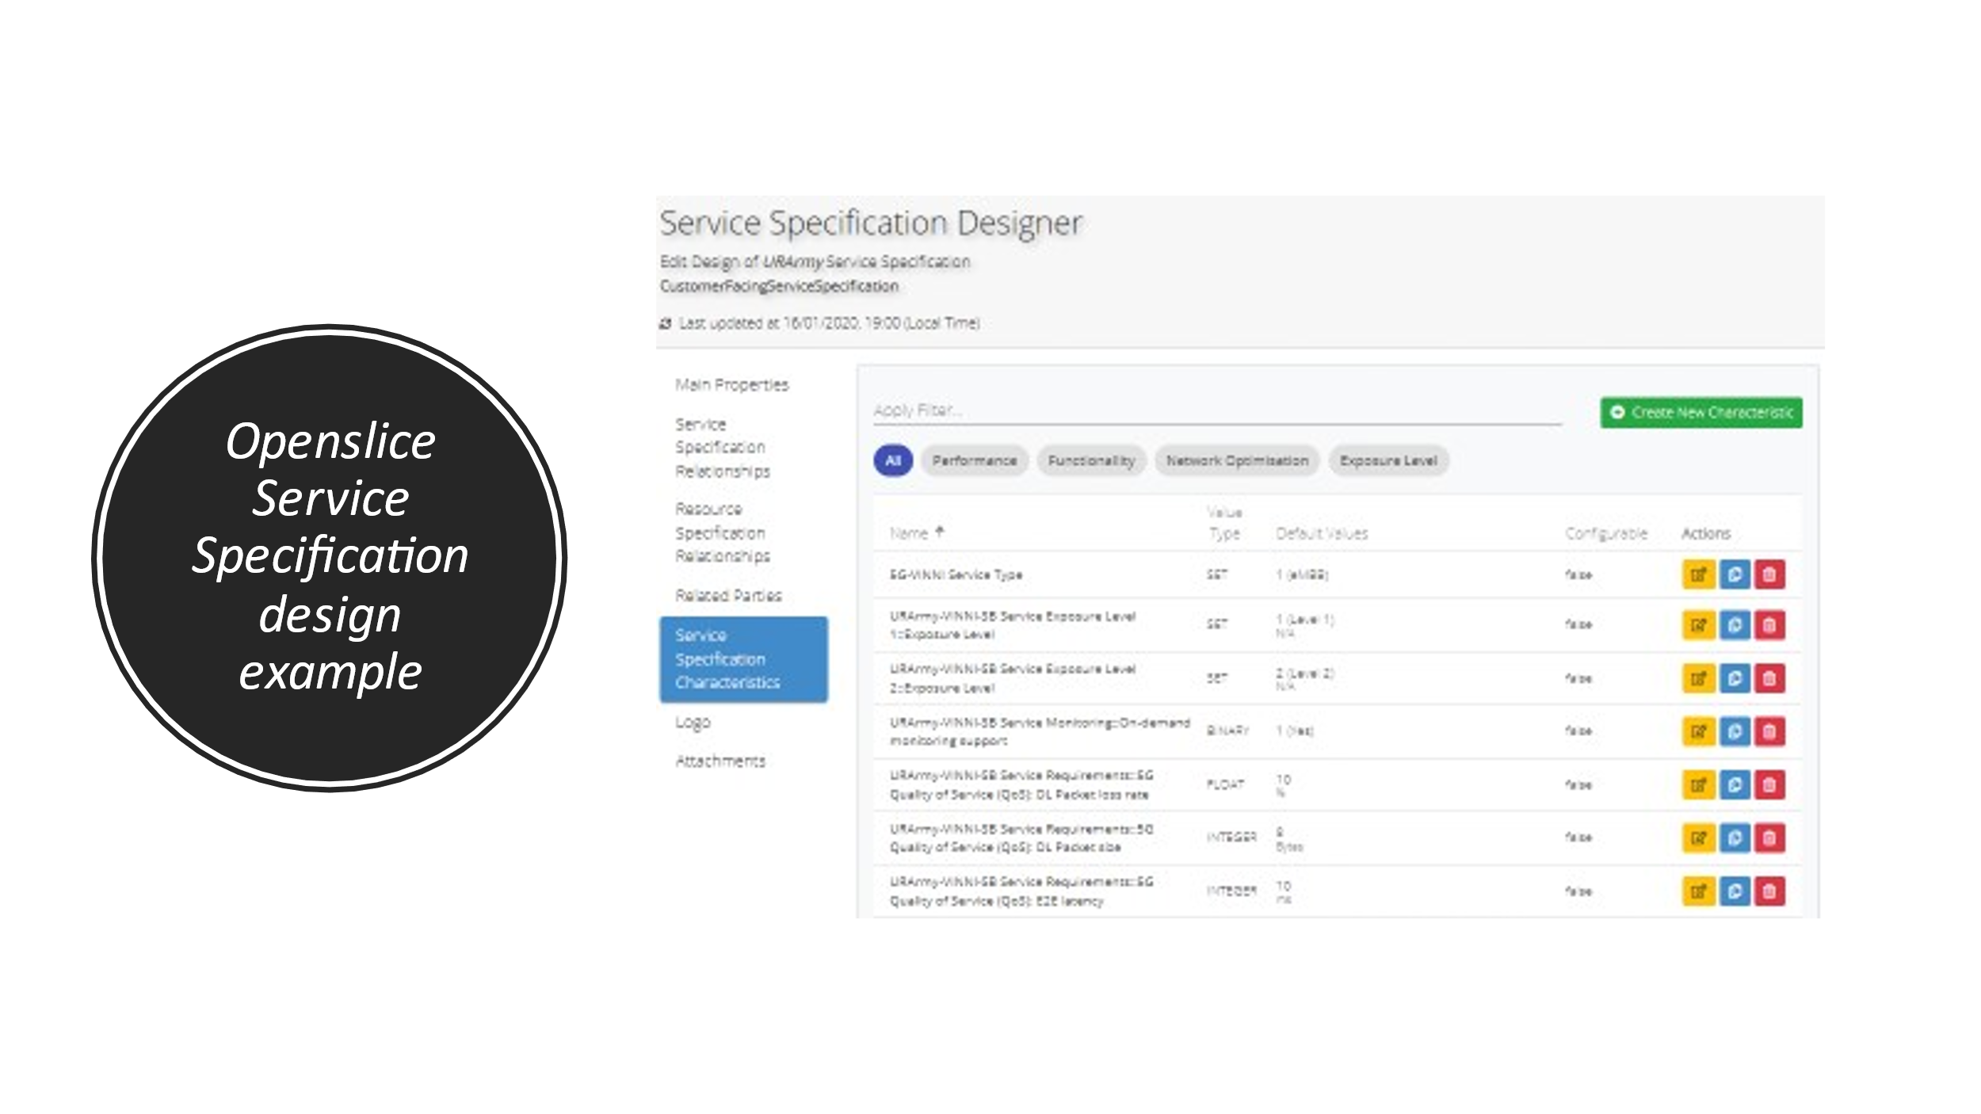

This Figure depicts an example of a Service Specification Design. Provided that Openslice has the underlying model from TMF, the users can either select to design their Service based on a GST or from scratch.

As mentioned, the Service Catalogue contains SBs. To allow a vertical to specify the characteristics of the slice he wants, 5G-VINNI defines a baseline, model-service template called 5G-VINNI Service Blueprint (VINNI-SB). The VINNISB defines a common information model for the whole facility, in order to enable a site-agnostic design of network slices. This not only enables reproducibility (the ability to generate repeatable instances of a given slice at different sites), but also cross-site deployments. Designed under the principles of reusability and customizability, a SB consists of a set of parameters that allow describing the capabilities that a vertical can get from a network slice. The Service blueprints can be predefined in the service catalog or they can be defined by the vertical. Openslice portal can store an organize into categories the service blueprints in order to be able to be used again by other verticals. When a vertical or a user cannot use a pre-existing SB for its test purposes, is able to create a new SB that can be based on a previous one.



A service blueprint is describing a given network slice to be provisioned using NSaaS. This service template is a structured document that provides a complete description of a given network slice, including information on service topology and expected behavior. Figure summarizes the structure of a SB. As shown, the content of VINNI-SB is arranged into four main parts: the Slice / Service Type (SST), the slice topology, the slice attributes and the slice monitoring & testing.

**Slice Service Type (SST)** is a 3GPP parameter that specifies the 5G service category the slice is meant to support. The following SST values are defined: “1” (eMBB), “2” (uRLLC) and “3” (mMTC). There is also a custom slice type SST>3 which allows for the definition of other slice types for example “SST=4” for Vehicle to everything (V2X) service.

**Service topology** which represents the default topology of the slice defines how the slice is constructed from a logical viewpoint by identifying i) the nodes which constitute a slice, including information on their individual functionality; and ii) how these nodes are connected with each other, including information on their connectivity type. A node can be mapped to a Network Service or a VNF depending on selected NFV criteria design. Examples of these nodes include 3GPP components (e.g. gNodeB, 5G core network functions (NFs)), value-added service functions (e.g. firewalls, NAT) and edge applications (e.g. virtual reality server, Cloud RAN). The slice default topology can be flexibly extended thus offering the verticals the opportunity to bring their own NFs and applications into slice definition by simply attaching them to define slice access points (red connection points in Figure 2).

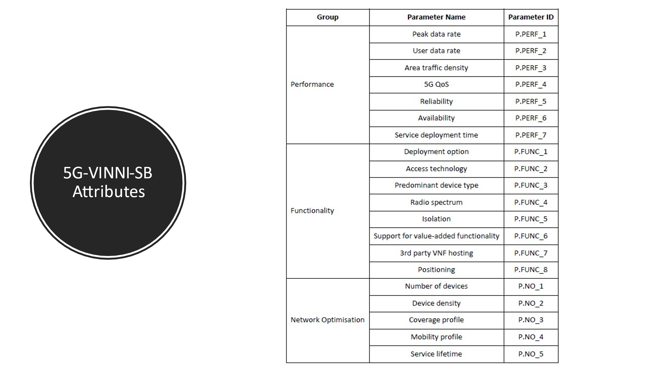

**Service attributes** correspond to generic network slice template (GST) attributes as defined in GSMA. The specification of values for these attributes allows the vertical to provide the service requirements the slice must satisfy, The attributes available in SB are listed in Table where for each attribute, the following information is defined:

* parameter value specification (e.g. integer, float, binary, etc.),
* measurement unit,
* selectable options (if needed) and
* conditional relationships with other parameters.

**Service monitoring and testing** allows the verticals to execute use case trials at run-time. This is relevant in experimentation environments and for service assurance and closed loop automation. *Service testing* allows the vertical to specify the tools to execute trialing activities within the slice.

*Service monitoring* on the other hand allows the vertical to specify telemetry information including data sources and metric collection methods (threshold-based alarms or periodic notifications).

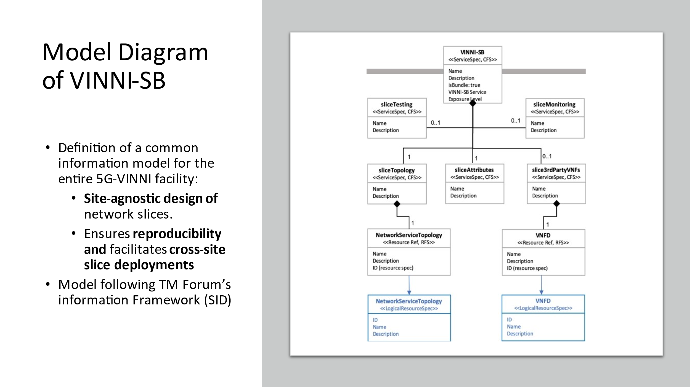

Following TM Forum’s Information Framework (commonly referred to as shared information and data model (SID)), the SB is a top-level construction that can be modelled as a bundle of classes, each defining the invariant characteristics and behavior (attributes, methods, constraints and relationships) of a component taking part in the structure of that top-level construction. For SB, the following classes have been defined: *serviceRequirements*, *serviceTopology*, *3rdPartyVNF*s, *serviceTesting* and *serviceMonitorin*g. Figure provides a unified modelling language (UML) representation of SID-driven SB model. The classes are of “ServiceSpec” type representing CFS aspects. In addition to these classes, the SB model also includes other types of classes, known as “LogicalResourceSpec” in SID terminology representing RFS aspects of the slice. Relationships between both types of classes allow establishment of mappings between CFS and RFS. For example, 3rdPartyVNF class has 1:1 relationship (reference, pointer) with the VNFD class, which represents the VNF information model.

With the above-referred VINNI-SB content, it is possible to provide a customer-facing service (CFS) description of any network slice which can easily be understood by the verticals. The CFS description can then be mapped into a resource-facing service (RFS) description of the slice, which provides details on how the slice is deployed at the resource layer. This means translating slice nodes and slice attributes into concrete Network Service Descriptors (NSD)/VNF Descriptors (VNFDs) along with instantiation information, e.g. placement of Network Services/VNFs and their resource allocation.

B. The NFV Services

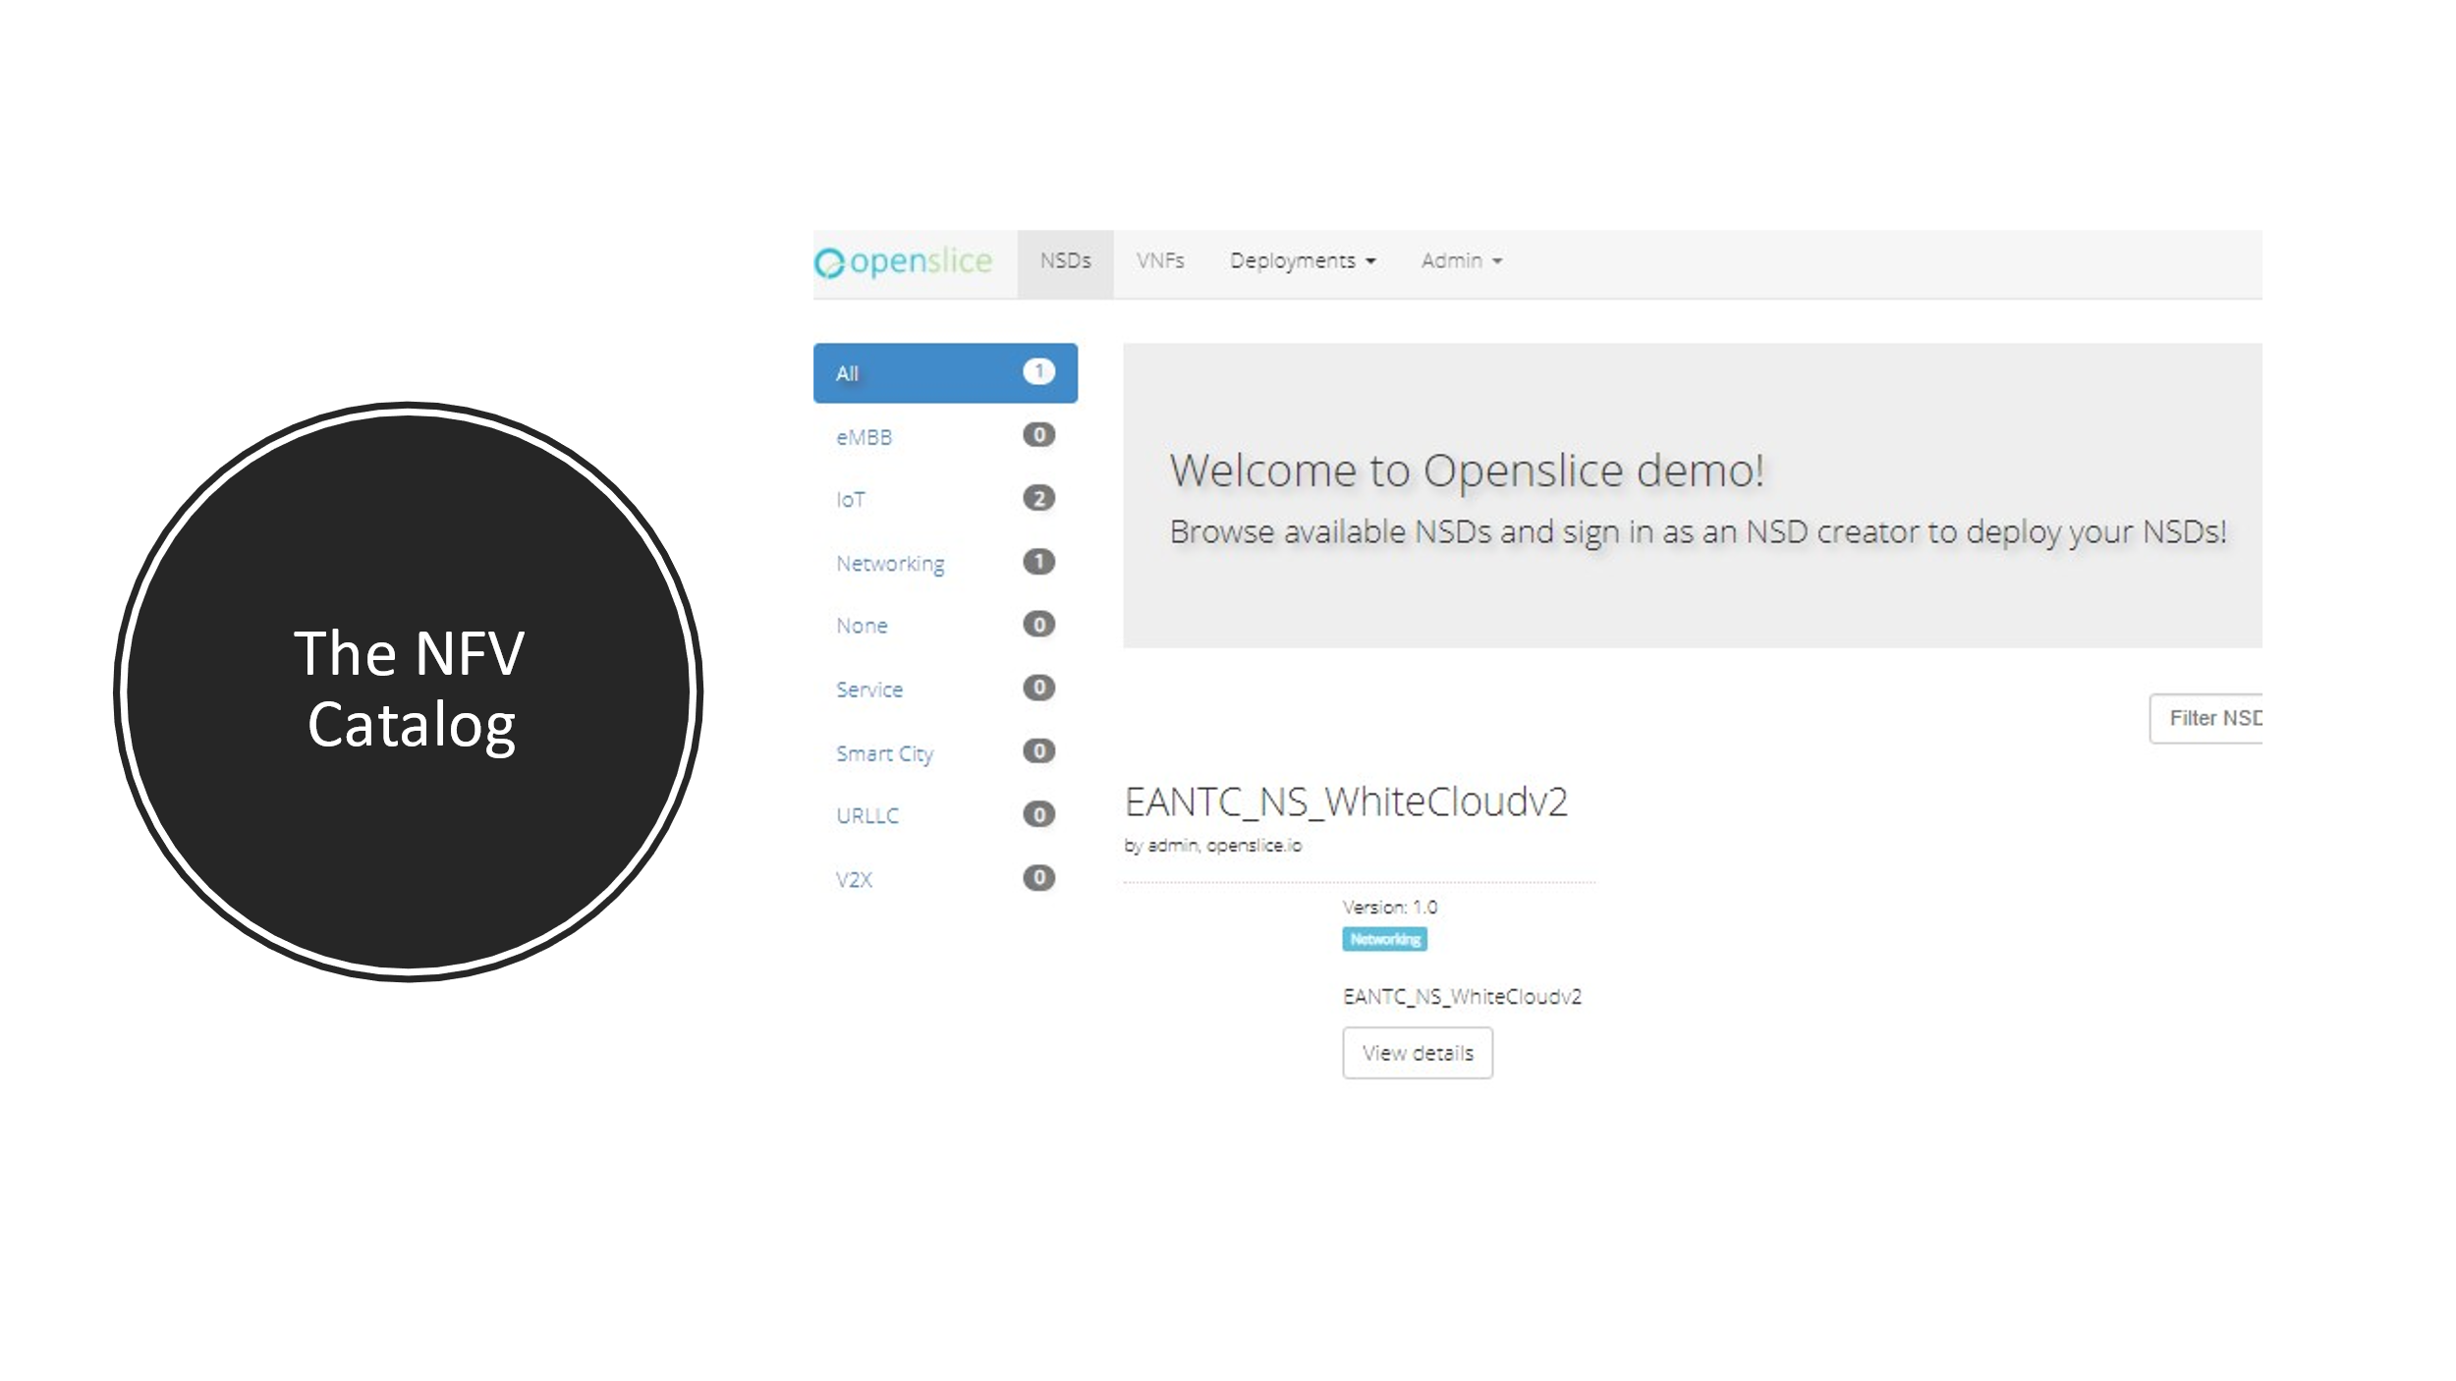

The NFV services provide to the operator a way to onboard NFV artifacts. These NFV artifacts are then onboarded to the interconnected NFVOs of Openslice.

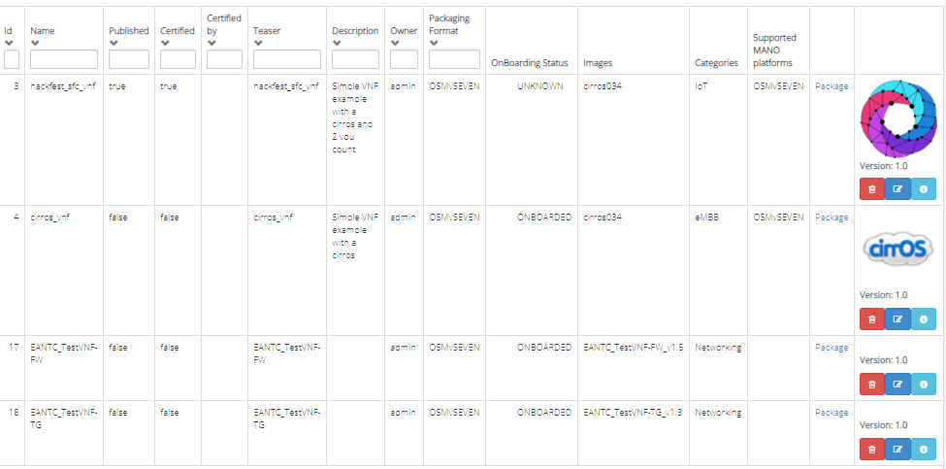

For example Figure displays available onboarded VNFs.

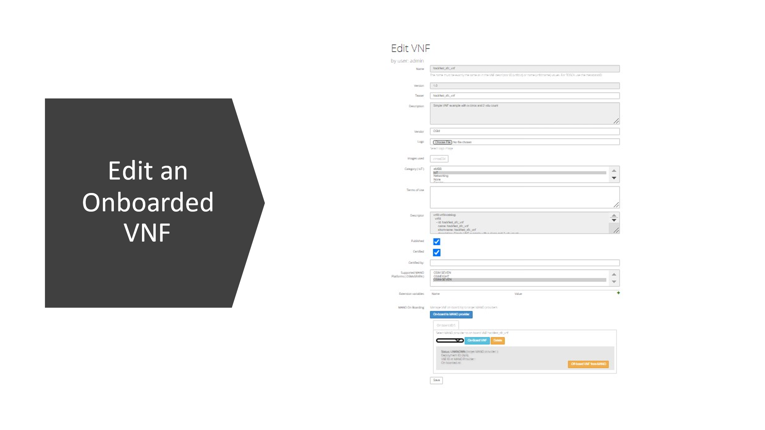

And this figure displays an example VNF and the status of this onboarded to target NFVO. In our case to OSM SEVEN.

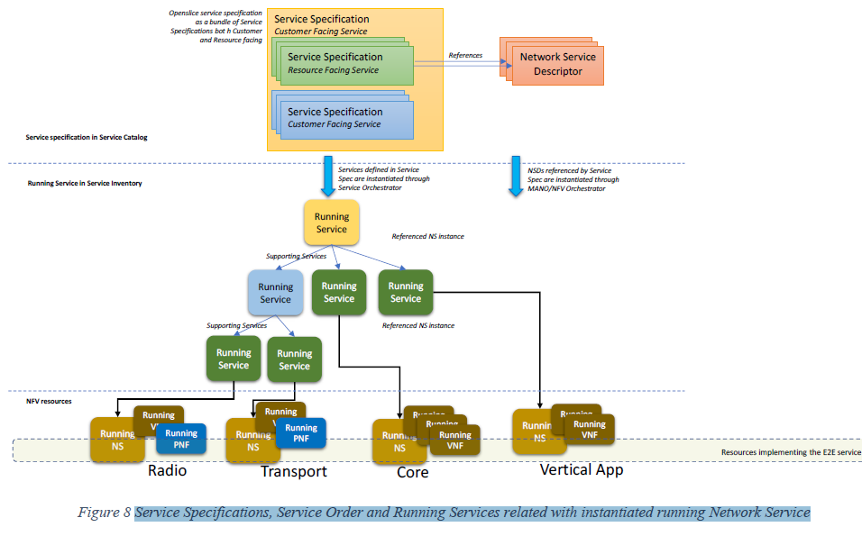

*The running Network Service*

Customers make Service Orders and Openslice instantiates the requested Service Specifications of the Service Order. Running Services instantiated by Openslice, reside in Openslice Service Inventory. The following picture displays how Service Specifications are related to Running Services and how Running Services relate with instantiated running Network Service.

Figure depicts how Service Specifications, Service Order and Running Services related with instantiated running Network Service. As discussed a Service Specification can consist of several other services, called as a Service Bundle. It consists of RFSs having each RFS related with underlying NSDs. The Service specifications defined in the Service Order are instantiated through the Service Orchestrator. The NSDs referenced by each RFS Specification are instantiated through MANO/NFV Orchestrator. So, there is a top-level Service instantiated reflecting the user service, e.g. eMBB 5G slice. This is decomposed and references 3 other Services which run and registered in Openslice Service Inventory. Other Running Services maybe further decomposed to other Services. This is done until each service is mapped to exactly one Running Network Service in the underlying Infrastructure. The Running NS is implemented by the VNFs and PNFs of the Communication Service Provider.

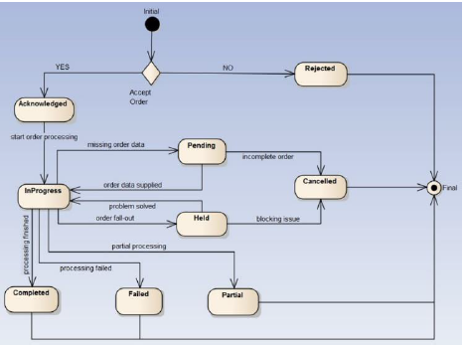

V. SERVICE ORDERING MANAGEMENT

Service Specifications reside into Service Catalogs, grouped in Categories. Openslice offers a Service Orchestrator called OSOM. OSOM instantiates Service Specifications by requesting Network Services from target MANOs/NFVOs. OSOM is a service responsible for:

* Service Order Management (SOM)
* Service Orchestration (SO)

It uses open source Flowable Business process engine (https://www.flowable.org). A Service Order follows the states as defined in TMF641 specification

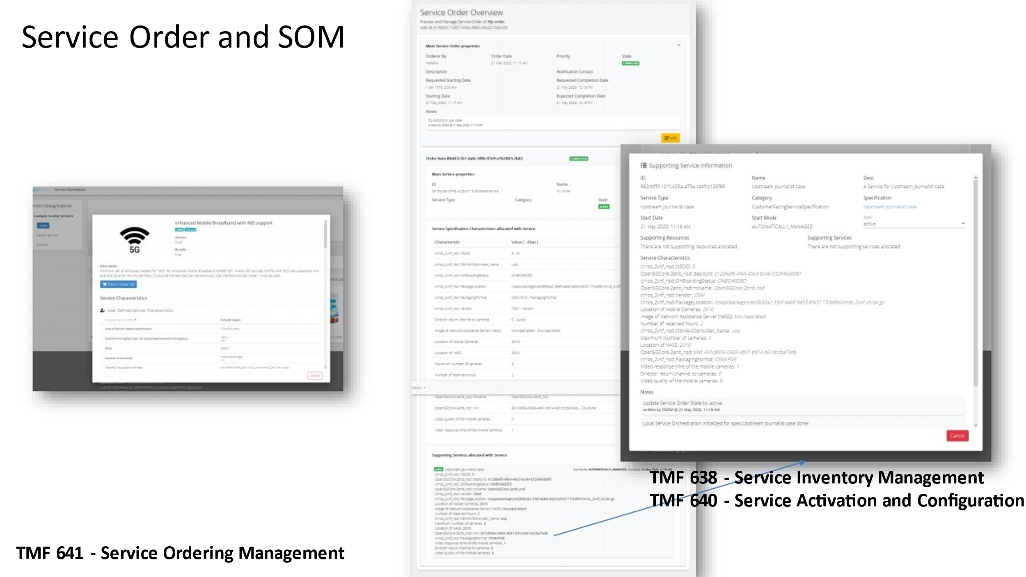

Figure displays a Service Order, while it is fulfilled by the OSOM. User is notified offline via automated emails by the issue management system when the service is ready. The other Figure displays the running service with information from the service inventory. For example IP addresses or other service status is available here.

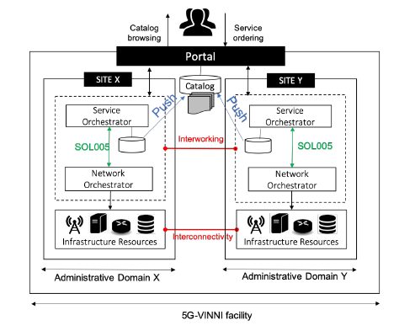

To allow site-agnostic of network slices, and eventually the deployment of slices across two or more sites, VINNI-SB defines a common information model for the whole 5G-VINNI facility. Taking advantage of this feature, 5G-VINNI facility collects the service offerings from the different sites, retrieving the VINNISBs from their catalogs and publishing them all into a single, centralized service catalog. This new catalog allows 5G-VINNI facility to provide a unified marketplace for verticals, facilitating their browsing and service orderings. Note that the responsibility of keeping the above catalog updated is up to every site. Every time the catalog of a given site suffers from any modification (e.g. on-boarding of a new VINNISB, update of an existing VINNI-SB), the corresponding network operator shall notify this change to the centralized catalog, using pushing mechanisms to that end. Every facility site operator designs their VINNI-SBs, according to the features deployed on their administrative domains. For example, there are some sites that do not have edge computing nodes, and hence are unable to offer a uRLLC VINNI-SB. The facility collects the VINNI-SBs from the different sites and registers them into a single service catalog. This approach allows providing verticals with a unified marketplace, informing them about available service offerings. Any vertical is in position to browse the service catalog, select the VINNI-SB that best fits his needs, and issue a service order. This service order will be translated into a network slice instance, deployed across one or more facility sites.

The Openslice provides a single entry-point for facility. Its mission is twofold. On the one hand, the portal support verticals customers taking the role of experimenters, in obtaining access to facility resources and available functionality (VINNI-SBs, testing and monitoring tools) for the purposes of use case trialing and KPI validation. On the other hand, the portal allows exposing the facility to verticals as a unified platform rather than as an interconnection of individual administrative domains, hiding the mechanisms, protocols and technologies adopted in every site.

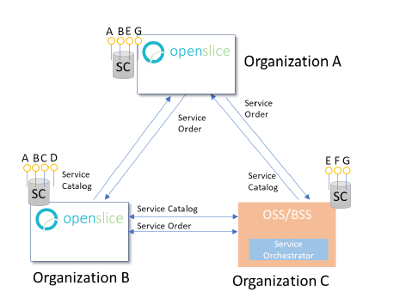

A typical deployment across domains, involves today some typical components: i) an OSS/BSS to allow customers access the service catalog and perform service orders, ii) a Service Orchestrator (SO) component for executing the service order workflow, as well as iii) a Network Functions Virtualization Orchestrator (NFVO) for configuring the iv) network resources.

TMF Open APIs are introduced not only for exposing catalogues and accepting service orders, but also implementing the East-West interfaces between the domains.

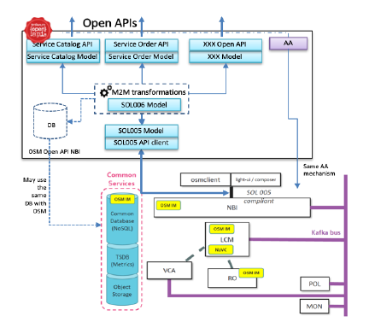

The Network Slice Provider offers TM Forum Open APIs, making them available for verticals, so they can invoke relevant NSaaS operations. To facilitate the handling of service catalogue, from VINNISB design to vertical-triggered service ordering, 5G-VINNI makes use of the following TM Forum Open APIs:

• Service Catalog API (TMF633), providing artifacts (e.g. models and dependencies) for the design of VINNI-SBs, and capabilities for their lifecycle management (e.g. registration, deletion, updating, etc.) in the service catalog.

• Service Ordering API (TMF661), for issuing a service order. This order conveys the information required to instantiation parameters. In some cases, this instance can be modelled as a network slice subnet instance.

• Service Inventory API (TMF641), which defines standardized mechanisms for CRUD operations over the records providing run-time information about deployed slice (subnet) instances.

• Service Configuration and Activation API (TMF640), providing capabilities to allow the operation of a deployed slice (subnet) instance. This includes the ability to trigger lifecycle management actions (e.g. creation, modification, update, deletion) over that instance, and the ability to define rules to collect monitoring data from that instance (e.g. using threshold-based alarms or periodic notifications).

As described, these TM Forum OpenAPIs may allow verticals to interact with the 5G-VINNI service catalog and consume the exposed capabilities.

In Openslice we can consume services from 3rd parties via Open APIs. We use the TMF 632 Party Management model to specify Organizations that we can exchange items and other information such as:

* Import Service Specifications
* Create a Service Order
* Use the Service Inventory to query the status of the service ordered to the external partner organization

Supported TMF APIs in Openslice as of today are the following:

* TMF 620 - Product Catalog Management
* TMF 622 - Product Ordering Management
* TMF 633 - Service Catalog Management
* TMF 634 - Resource Catalog Management
* TMF 638 - Service Inventory Management
* TMF 640 - Service Activation and Configuration
* TMF 641 - Service Ordering Management
* TMF 666 - Account Management specification
* TMF 669 - Party Role Management
* TMF 629 - Customer Management
* TMF 632 - Party management

**Supported APIs**: http://portal.openslice.io/tmf-api/swagger-ui.html

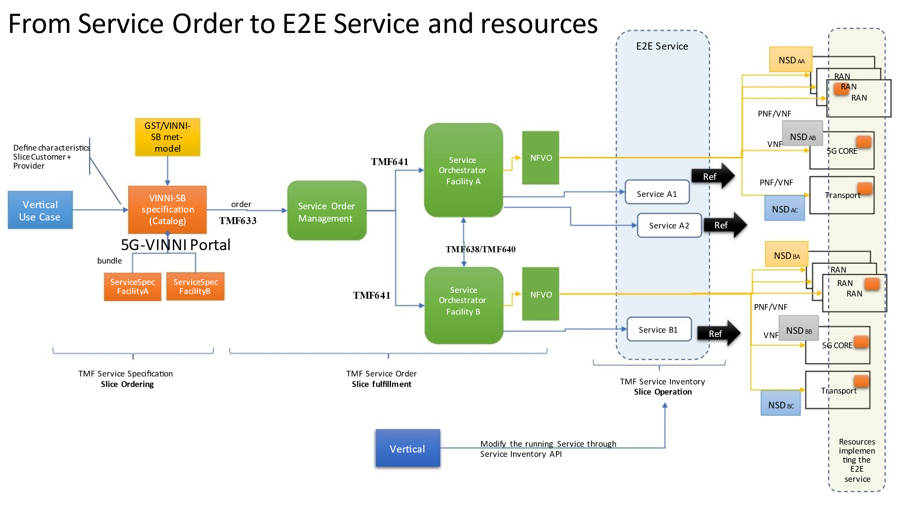

High level from service order to E2E Service

It is assumed that Slice Ordering is initiated from a 5G Vertical (a NS Customer), by ordering specific Service Specifications that are related with Network Services. These Service Specifications are located in a Service Catalog of the provider. Both Specification and Service Catalog follow the model of (**TMF633**), which provides artifacts (e.g. models and dependencies) for the specification of Services. We have two types of Service Specifications: Customer Facing Services (CFS) and Resource Facing Services (RFS). CFSs are exposed to the catalog and users can order them. RFSs are internal and related with the underlying resources. Assuming these service specifications follow the GST model, the derived NESTs are modeled as TMF Service Specifications. Actually from a GST meta-model a TMF model is created.

A NEST (a Service Specification) can consist of several other services, so we call it a **Service Bundle**. It consists of RFSs having each RFS related with underlying NSDs(VNFs) for radio, core, or other applications. For example, a service spec for a 5G Slice on Country Greece and Location Athens, might consists of RFSs that will configure via VNFs and PNFs, RANs in Athens and create a new 5GCore while configuring an existing transport network. Thus, the Customer requests the Service Spec and creates a Service Order. Service Orders are modeled with the **Service Ordering API (TMF641),** which allows issuing a service order, and includes selected Service Specifications as well as instantiation parameters. (e.g. Network Slice region, QoS, Number of UEs, etc ) The **slice fulfillment phase** begins when the customer triggers a service order from the service catalog. In this service order, the customer provides a completed specification of the slice instance he wants, including information on slice topology (possibly extended with 3rd party VNFs) and slice attributes (filled in with values fitting use case requirements). To do that, the vertical makes use of the Service Ordering API. The issued service order is then captured by the Service Order Management (SOM)*,* which propagates it towards the corresponding g Service Orchestrator(s) again via TMF641 API calls. Next, the service order is processed.

This processing consists in translating the received service order (CFS, handled by the Service Orchestrator) into a set of resource requirements for the network slice to be instantiated (RFS, handled by the NFVO). To successfully achieve this translation, Service Orchestrator and NFVO exchange information relying on ETSI SOL005 capabilities. Once this translation is completed, the NFVO allocates the slice instance, instructing the VIM for that end.

At this stage we have the E2E network service running involving Radio, 5G Core, Transport or any other desired Network Service (e.g. a firewall). *3) Slice Operation*

As described, TM Forum OpenAPIs may allow customers not only to interact with the service catalog but also to consume the exposed capabilities.

In the **slice operation phase,** the slice is already instantiated, and can be made available for operation. During this phase, the customer keeps track of the status of the slice instance, making use of the Service Inventory API **(TMF638),** which defines standardized mechanisms for CRUD operations over the records providing run-time information about deployed slice instances.

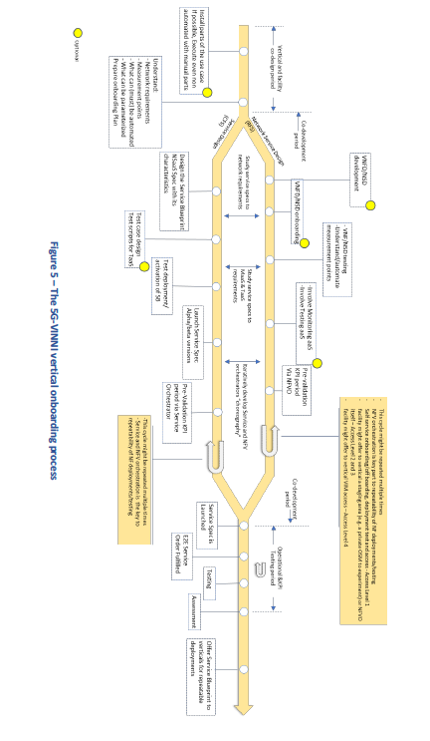

2 ONBOARDING

This Figure displays the vertical onboarding process. The process consists of several phases which are discussed in

detail in subsequent sections.

1. **The co-design period of more generally the design period**

Since orchestration is a key part of automatically configuring, activating and deactivating services and network slices in a repeatable fashion, certain components must be developed based on the vertical requirements and the capabilities of the facility. This development will lead to the automated deployment by the orchestrator. The Supported NFV Models and (YANG, and TOSCA). During the orchestration several exposed parameters from the vertical services can be parameterized and reconfigured.

ii) co-development period. We identify here two main processes:

i) the Network Service Design process which is related to resource facing services (RFS)

ii) the Service Design process which is related to customer facing services (CFS)

2.2 CO-DEVELOPMENT PERIOD– SERVICE DESIGN PROCESS (CFS)

In this phase the development of service blueprint based on the requirements defined. These

requirements are “translated” towards the SO and NFVO. The SB will be used to automatically

trigger the complete orchestration of the network slice instance. Proper definition of the SB requires some work initially but this will benefit the vertical customer to consequently reproduce the service instantiation via the service catalogues with potential minor updates to the SB. Then the SB is prelaunch/pre-ordered via the Service Orchestrator which also involves validation of the Taas and MaaS to be correctly orchestrated.

The SB has the option to include testing as a service (TaaS). For example, by including relevant test scripts for TaaS. The test scripts will represent specific Test Cases (TCs) that are targeted at stressing specific aspects or KPIs of the Service. It is important to understand that there are two types of TCs: 1) TCs for validating fundamental network KPIs like throughput, delay, and 2) TCs for validating the service of the vertical customer that might include the vertical’s application. While the former can be offered as part of the service design with minimal configuration, the latter might require significant work.

The SB is pre-launched/pre-ordered via the portal in order to validate that can be correctly orchestrated via the SO. In this step, the facility tries to instantiate, test and validate the defined SB. This is also related to developments in Openslice itself as well as development in the SO part. During this step, the SB attributes might be redefined based on the interaction with the facility. Since the SB is instantiated and validated successfully, the facility can start launching different versions of the SB towards the SO and NFVO while involving TaaS and MaaS, checking and assessing their interoperability. A validation is also needed for the proper deployment of the Network service and thus verify that the developed CFS can extract the proper KPIs. This process might also involve TaaS. By invoking TaaS during

service deployment, we can validate the the SB and TaaS/MaaS work as expected. Testing as a Service (TaaS) and Monitoring as a Service (MaaS) can be integrated during the preparation of the VNFs and development of service templates. This is subject to availability of TaaS and/or MaaS in the facility site. After the valdation the vertical customer

can make repeatable and scheduled service orders of the developed service blueprint via the portal and perform KPI testing, monitoring and assessment.

2.3 CO-DEVELOPMENT PERIOD - NETWORK SERVICE DESIGN PROCESS (RFS)

The Network Service design process is related with the NFV specifics of onboarding. This process is iterative and interacts

with the Service Design process. The vertical customer is able to on-board any additional VNFs during orchestration. For such purpose a development of VNF/NSD is needed. Prior to development of VNFs/NSDs, the developer must understand the specifics of the target 5G facility and plan for any specific requirements (e.g., hardware acceleration, Internet access for VNF). Creating VNF packages or Network Service descriptors is a tedious task and depends on the target NFV Orchestrator (e.g. OSM, Nokia CloudBand Network Director) and the standard followed. For the creation of VNFs the following should be considered:

* Preparing the Virtual Machine image
* Implement a VNF descriptor according to target orchestrator model
* Implement any configurations related to the VNF Manager and especially the Element Management System (EMS). EMS is responsible for the functional management of VNF, i.e. FCAPS (Fault, Configuration, Accounting, Performance and Security Management), which often involves VNF management using proprietary interfaces.
* VNF packaging

Similarly, for Network Service descriptors, the task includes:

1. Creating folder structure
2. Completing the NSD YAML file, with the Network Service metadata, constituent VNFDs and Virtual Link Descriptors
3. Packaging the Network Service

After the development, the VNFD/NSD ONBOARDING can be performed. Usually, the testing of the VNF/NSDs can be performed through the orchestrator by directly accessing it.

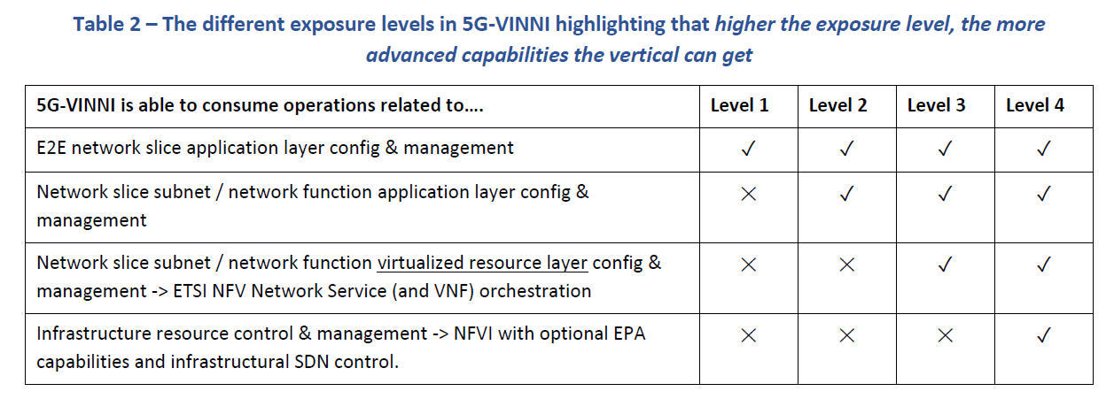

Depending on the different exposure levels the following options might be available to the vertical customer:

* Manual onboarding of VNFD/NSD performed by the 5G facility operator.
* Self-service onboarding/off boarding, deployment test and access (Exposure Level 1)

Automated self-service onboarding can be done by Openslice NFV portal when offered by the 5G facility

* The 5G facility might offer a staging area (e.g. a private OSM to experiment) or offer the use of the production

NFVO itself (Exposure Level 2 and 3)

* The 5G facility might offer VIM access (Exposure Level 4)

The vertical customer must upload any VM images to the 5G facility so that these can be stored in the image repository.

Further to the NSD Validation it is recommended to test the NSD orchestration only by the NFVO to identify any errors.

The VNFDs and NSDs can be repeatedly orchestrated and instantiated without errors, by on boarding the VNFDs and NSDs to the production NFVO of the 5G facility via its tools and processes.

Optionally, the vertical customer should consider the involvement of monitoring and testing services during VNFD and NSD development. Such services can be consumed both as a human-driven or an automated interaction.

TaaS consists of a set of testing tools that can be deployed, configured, and automated through a set of offered web

services. A typical example of testing tools is traffic generators, that can emulate realistic traffic and protocols.

The offered services allow the vertical customer to:

* onboard specific drivers for automating vertical applications and use cases
* create and execute individual test scripts for automating the tests or the experimentation
* create and execute test campaigns, i.e. batch of test scripts that can be executed on multiple target

infrastructures

* visualize logs and results through the offered visualization systems
* allow the vertical to develop customized visualizations

In order to better understand how to consume a TaaS service, an example is depicted in Figure .

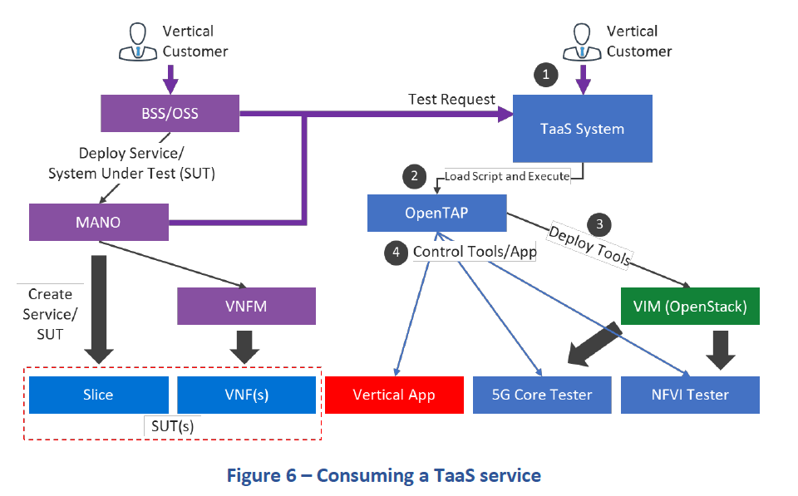

In Figure, two examples are depicted for how to consume the testing service. The first case is for service validation.

While deploying the Network Service, a set of test cases can be automatically requested by the BSS/OSS and executed

after the deployment in order to verify the health or performance of the service. In this case the test cases are

programmatically requested via API calls (TaaS APIs are not yet published) to the TaaS. The other way of consuming the service is using web services (TaaS web services are available and will be supported for 5G-VINNI Release 2), that allow manual execution of the tests. The manual execution allows for a more comfortable way of configuring the tests to perform more exploratory experiments. After the tests is requested (1), the test scripts present in the TaaS repository are loaded and executed on OpenTAP, an open source technology that is at the heart of the 5G-VINNI TaaS system. OpenTAP allows to programmatically deploy tools e.g. in an OpenStack cloud, and configure them to target the newly deployed service.

At last and since CFS and RFS are in place, an official Testing period can start according to the facility plan. This process is again iterative and if necessary, developers might revisit previous steps. The following steps are planned.

1. The latest developed 5G-VINNI-SB is officially launched in the 5G facility catalogue and ready for service orders.
2. The Service Order takes place and the subsequent services are instantiated.
3. Then the actual testing takes place, either through automated scripts or via user interactions. The results of the testing will be stored in heterogeneous data stores.
4. Finally an assessment of the data is performed

After the testing and validation period the defined SB can be offered in a centralized manner for repeatable deployments.

Monitoring Capabilities

The facility can provide remote access to its monitoring infrastructure via a VPN to involved partners providing monitoring data and metrics related to the Cloud infrastructure itself and also for all the VNF health. This architecture can be expanded to collect monitoring data directly from the VNFs and Physical Network Functions (PNFs). An instance of Prometheus should be provisioned inside the cloud, which will establish a channel of communication between the VNF’s which will be used only for monitoring and management purposes. Over this network Prometheus will collect data from the VNFs that will contain and run an instance of NETDATA software. NETDATA will provide a REST API that will be accessible from the management network. NETDATA is also be able to collect data from RAN but this needs some development. This information will be used to evaluate KPI’s.

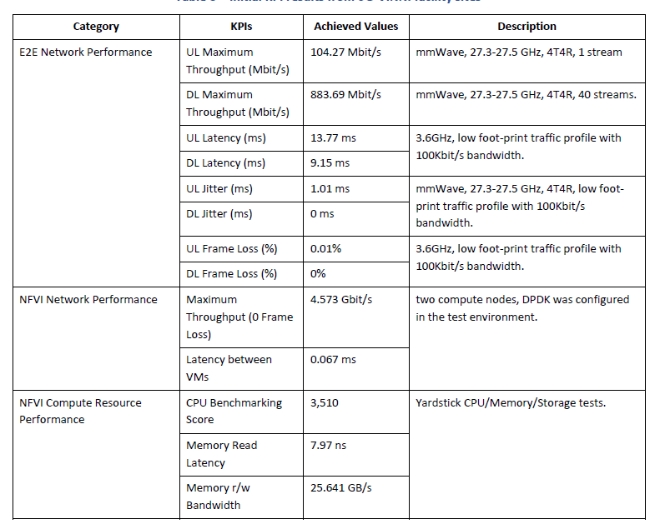

Some initial KPIS can be exported by run some test cases using open source and commercial testing tools, in order to measure the capabilities of the current infrastructure that can be used by verticals.

The test categories include:

* **End-to-End Network performance**: End-to-End measurements have been carried out by using handsets and CPEs in order to validate which type of performance the Vertical applications might expect.
* **NFVI Network Performance**: the network fabric of the entire infrastructure has been tested to verify the solidity of performance in supporting the NFV architecture.
* **NFVI Compute Resource Performance**: these tests have been needed to verify if the NFV hardware profile was capable of supporting the NFV architecture.

The results of such tests can be seen in Table.